Stretta Therapy
When patients suffer from chronic gastroesophageal reflux disease (GERD) that is not well controlled with medications, or where long-term medications are not a viable option, Stretta offers an alternative other than surgery and implants. Stretta is a unique and non-surgical outpatient procedure that takes about an hour, with patients returning to normal activities within a few days. Studies show that Stretta resolves reflux symptoms and improves quality of life and reduces or eliminates medications and reduces acid exposure. It is a Non-surgical treatment delivered transorally (through the mouth) and the clinical studies all conclude it is safe and effective with the long-lasting results.

The FDA originally cleared Stretta for use in 2000 and issued an updated clearance on the RF1 generator in 2011. Clinical studies demonstrate that Stretta RF treatment results in significant reductions in tissue compliance and transient LES relaxations, as well as increased LES wall thickness due to muscle growth. These mechanisms restore the natural barrier function of the LES and reduce spontaneous regurgitation caused by transient relaxations of the sphincter, two of the leading causes of GERD. Stretta is typically performed on an outpatient basis with conscious sedation.

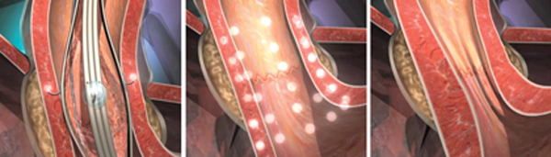

Dr Wu and his experience of Stretta procedure
After a number of successful Stretta procedure, Dr Wu, Wen-Chieh was one of the first group who qualified with complete global 3-course training certification of Stretta in Asia Pacific. Dr. Wu learned Stretta procedure from Dr. Mark Noar, the gastroenterologist in Towson, Maryland and is affiliated with multiple hospitals in the area, including Greater Baltimore Medical Center. Then, he also learned Stretta procedure and endoscopic interventions from Dr. Kenneth J. Chang, the chief of the Division of Gastroenterology at UC Irvine.

Currently, Dr. Wu, Wen-Chieh is the instructional doctor for Stretta Procedure in Asia and is the Chief of Gastroenterology Division, at Yuan-Sheng Hospital.

